

OTC-VPC Terraform Provider and Gophercloud

Functional Spec

December 8, 2017

Sapan Vaswani

Email: sapan.vaswani@click2cloud.net

Version History

|  |  |  |  |
| --- | --- | --- | --- |
| **Version** | **Date** | **Name** | **Description of Change** |
| 1.0 | 2017.12.8 | Sapan Vaswani | Initial Document Creation |
|  |  |  |  |
|  |  |  |  |

Reviewers

|  |  |  |  |
| --- | --- | --- | --- |
| **Name** | **Version Approved** | **Role** | **Date** |
| Sandeep Thakre |  | PM | 2017.12.8 |
|  |  |  |  |
|  |  |  |  |
|  |  |  |  |

Table of Contents

Introduction 4

Objectives 4

Project Scope 4

Out of Scope 5

Assumptions 5

Architecture 6

Architecture Overview for OTC-VPC Gophercloud 6

Component Structure 6

Architecture Overview for OTC-VPC Terraform provider 7

Component Structure 7

Prerequisite 7

Operating Environment 7

Software Used: 7

Dependencies 7

File Names and Structure 8

Disclaimer 9

Appendix: Glossary 9

Point of Contact 10

# Introduction

## Objectives

The objective of this document is to describe technical and functional specification on OTC-VPC Terraform Provider and Gophercloud. This document covers scope and detailed on different parameters supported by interfaces. This deliverable will cover the implementation of OTC VPC interface in Gophercloud and relative terraform provider service for Virtual Private Cloud (VPC).

In a cloud environment, various users’ resources must be kept separate. This can be achieved by each user creating a Virtual Private Cloud. With the Virtual Private Cloud, an internal Open Telekom Cloud IP address range is reserved which can only be accessed by authorized users. This ensures that other users cannot access the services there, even by accident. The Virtual Private Cloud then acts as the user’s individual (small) cloud. Creating a Virtual Private Cloud is an effective, basic security measure. Resources in the Open Telekom Cloud can only be allocated and managed via a VPC. Every user needs at least one VPC.

In this project, our main goal is to automate provisioning of OTC-VPC service using terraform provider with support from gophercloud.

## Project Scope

Terraform is used to create, manage, and manipulate infrastructure resources. Examples of resources include physical machines, VMs, network switches, containers, etc. Almost any infrastructure noun can be represented as a resource in Terraform.

So as a part of project scope, Click2Cloud would develop and deliver following to automate the provisioning using Terraform Provider;

* 1 custom Gopher SDK for OTC Cloud VPC Service Client with following API interactions.

|  |
| --- |
| **VPC** |
| Creating a VPC |
| Querying VPC Details |
| Querying VPCs |
| Updating VPC Information |
| Deleting a VPC |

* 1 Terraform Data Source and 1 Terraform Resource for OTC-VPC service

|  |
| --- |
| **Terraform Data Sources** |
| otc_vpc (Query) |
| **Terraform Resources** |
| otc_vpc(Create, Update, Delete) |

## Out of Scope

1. Other tasks than above task, for which development will be done, are not in the scope of project.
2. Gophercloud Authentication mechanism would not be customized as VPC service client is part of scope.
3. Resource and data source will be tested using open source terraform for windows. Scope does not cover testing on Terraform Enterprise.
4. Apart from English language, other languages such as Chinese is not considered.
5. Hashicorp approval is not a part of scope.

## Assumptions

1. The technical platform such as OTC authentication details, terraform and otc terraform provider and gophercloud is available.
2. Gophercloud Authentication mechanism will be used as is without any customization with username, password, tenant_id, etc.
3. Change in any functional requirement documented below shall be treated as CR (Change Request).
4. This document to be freeze and sign-off before implementation start.
5. Tasks mentioned in the Out of Scope are not part of requirement.
6. All interfaces which need to integrate with terraform provider, are finalized by Huawei Team under SOW.
7. Resource and data source will be tested using open source terraform for windows. Scope does not cover testing on Terraform Enterprise.
8. Any update within REST API should be informed to Click2Cloud Team. Click2Cloud will do required analysis and will identify the impact. If the impact is significant, then it will be communicated to stakeholders for further decision.
9. All the supporting document will be provided in English language only.

# Architecture

## Architecture Overview for OTC-VPC Gophercloud

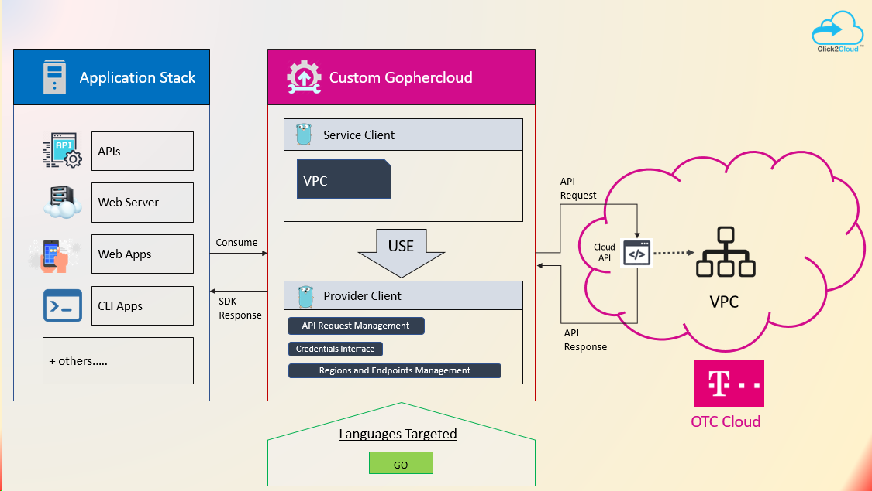

## Component Structure

As the image above:

1. Gophercloud is the OpenStack SDK for GoLang, which will handle the VPC service API interaction for OTC.
2. The service client will use provider client for authentication and API Request management.
3. It will be consumed by Terraform Provider to automate infrastructure provisioning.

## Architecture Overview for OTC-VPC Terraform provider

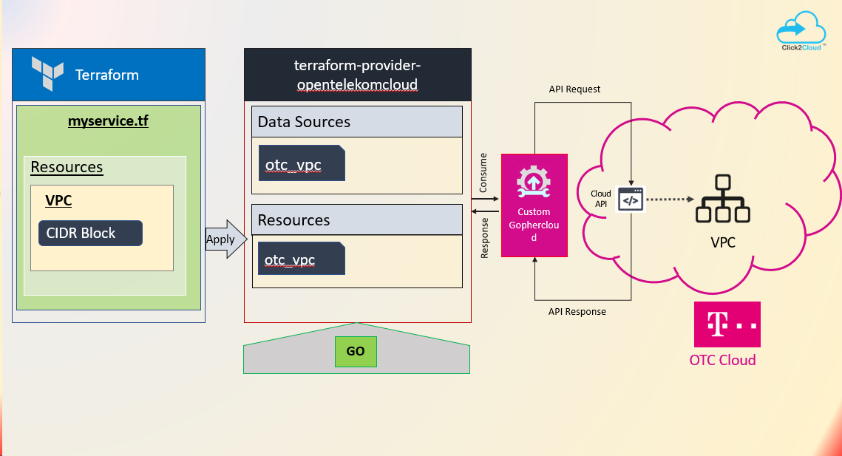

## Component Structure

As the image above:

1. terraform-provider-opentelekomcloud is the extension of terraform to communicate with OTC services.
2. Gophercloud is the middle layer, the OpenStack SDK for GoLang, which will handle the VPC service API interaction for OTC.
3. The SDK will be consumed by Terraform Provider to automate infrastructure provisioning.

# Prerequisite

## Operating Environment

### Software Used:

**Gopher SDK** - go1.9.2 windows/amd64

**Terraform** - Terraform v0.11.1

## Dependencies

* Access/Credentials to OTC Cloud environment to create, update, delete VPC.
* Forked/cloned repository of official Gopher cloud repository would be shared by client with admin/full access.
* Access to OTC Terraform provider repository where the data source and resource need to be developed
* The timelines specified are tentative and can change based on the priority of items to be delivered, delay in any approvals required from Huawei, infrastructure issues from Huawei.

# File Names and Structure

1. Gophercloud File Structure

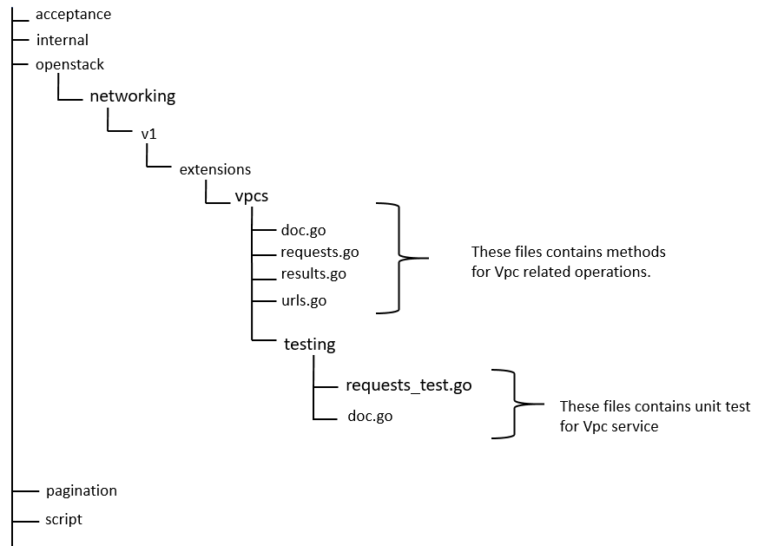

1. OTC Terraform Provider File Structure

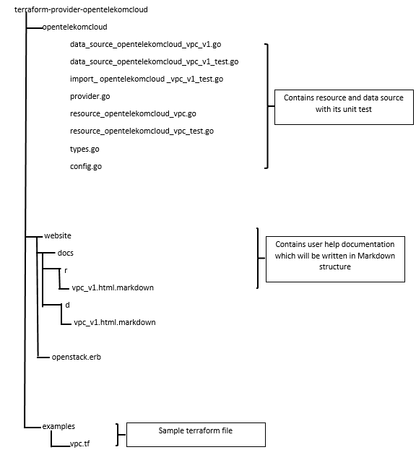

# Disclaimer

This **DRAFT** Specification is being forwarded to you strictly for informational purposes and sign-off requirement before development starts. The specification is "AS IS," "WITH ALL FAULTS" and Click2Cloud makes no warranties, and disclaims all warranties, express, implied, or statutory related to the specifications. THE CORPORATIONS ARE NOT LIABLE FOR ANY INCOMPLETENESS OR INACCURACIES. THE CORPORATIONS ARE NOT LIABLE FOR ANY CONSEQUENTIAL, INCIDENTAL, OR INDIRECT DAMAGES RELATING TO THE SPECIFICATIONS OR THEIR USE.

# Appendix: Glossary

|  |  |  |
| --- | --- | --- |
| No. | Initial Name | Description |
| 1 | CR | Change Request |
| 2 | FSD | Functional Specification Document |
| 3 | VPC | Virtual Private Cloud |
| 4 | OTC | Open Telekom Cloud |

# Point of Contact

|  |  |  |
| --- | --- | --- |
| **Name** | **Designation** | **Email** |
| Sandeep Thakre | Project Manager | [sandeept@click2cloud.net](mailto:sandeept@click2cloud.net) |
| Sapan Vaswani | Lead Software Design Engineer | [sapan.vaswani@click2cloud.net](mailto:sapan.vaswani@click2cloud.net) |
|  |  |  |
|  |  |  |
|  |  |  |